**Table of Contents**

**Table of Contents** 1

1. Functional Design Overview 2

2. Functional Description 2

3. Detail Requirements 2

4. Initiating/Triggering Process 3

5. Key Considerations & Assumptions 3

6. Security Requirements 8

7. Error Handling 8

8. Special Considerations 8

# Functional Design Overview

## Functional Description

Currently, student performance on GBI Case Studies is recorded and displayed in a Fiori app, Global Bike Monitor, that enables the professors to see student performance on each step for a specified Case Study. This functional requirement is to make the information in the GBI monitor available in JSON format through an API to be consumed by another application, Gamified GBI Web App.

Use OData services instead of APIs

Fiori app design for the gamified application

Mendex and Neptune platforms for the GA work done in the past

SAP Build can do the similar function as Mendex ad Neptune

## Detail Requirements

From the Global Bike Monitor app, I would like the following output through the API in JSON Format.

**Output:**

* User column – e.g., Learn-001, Learn-002, Learn-003 etc.
* Each step in the module – e.g. Step 1, Step 2 … Step 23
* For each step in the module, did the user had it correct, warning or wrong? i.e. - green, yellow, or red traffic light symbol converted into numeric scores
  + - Green – 10 points
    - Yellow – 7 points
    - Red – 5 Points
    - Empty – 0 Points
* The percentages of completion

## Initiating/Triggering Process

Anytime a user logs into the Gamified GBI Web Application, there will be a request from the application to access the API end point to fetch data specific to that user.

## Key Considerations & Assumptions

The users, will use the same login User ID, for example LEARN-001, use in the S/4HANA Cloud system in the Gamified GBI Web Application

**Points -**

* GREEN =Each correctly completed step earns 10 pts à @08@
* YELLOW =Partially completed step earns 8pts à @09@
* RED =Wrongly completed step earns 7pts à @0A@
* EMPTY = Uncompleted step earns 0pts à “”

**Levels -**

* Each step completed moves the user to a new level. E.g. when the user completes 5 steps, no matter whether it is completed correctly, partially, or wrongly, the user has 5 levels.
* The only time the user doesn’t not move in a level is when the step was not completed (uncompleted step earning 0 pts)

**Badges -**

* Badges are awarded based on the scope of work done.

**For MM, there will be 5 badges.**

* + Login Badge - Badge for signing into the gamified web app.
  + Master Data Badge - Badge awarded for completing steps 1 to 3 (Vendor and Material Master data creation)
  + RFQ Badge - Badge awarded for completing steps 5 to 9 (Quotation related steps)
  + PO Badge - Badge awarded for completing steps 10 to 14 (Purchase Order Steps)
  + FI Badge - Badge awarded for completing the finance steps 20 to 24 (Post supplier invoice, post outgoing payment)
* Badges are awarded based on the scope of work done.

**For SD, there will be 5 badges.**

* + Login Badge - Badge for signing into the gamified web app.
  + Master Data Badge - Badge awarded for completing steps 1 to 3 (Customer Master data creation)
  + Quotation Badge - Badge awarded for completing steps 4 to 5 (Quotation related steps)
  + Sales Order Badge - Badge awarded for completing steps 6 -10 (Purchase Order Steps)
  + Billing Badge - Badge awarded for completing the finance steps (Steps related to customer billing and payment receipt)
* Badges are awarded based on the scope of work done.

**For FI-AR, there will be 5 badges.**

* + Login Badge - Badge for signing into the gamified web app.
  + Master Data Badge - Badge awarded for completing step 1 (change customer payment terms)
  + Invoice Badge - Badge awarded for completing step 2 (Create customer invoice)
  + Payment Badge - Badge awarded for completing steps 4 (Post incoming payment)
  + Scenario Badge - Badge awarded for completing steps 6 to 8 (Performing scenarios 1 through 3)
* Badges are awarded based on the scope of work done.

**For FI-AP, there will be 5 badges.**

* + Login Badge - Badge for signing into the gamified web app
  + Master Data Badge - Badge awarded when step 1 to 4 is completed (Bank Account, GL, and Vendor Master data creation)
  + Funds Badge - Badge awarded for completing step 5 (Posting fund to alternate account)
  + Invoice Badge - Badge awarded for completing step 7 (create an invoice for rent)
  + Payment Badge - Badge awarded for completing step 10 (Post payment to landlord)
* Badges are awarded based on the scope of work done.

**For PP, there will be 5 badges.**

* + Login Badge - Badge for signing into the gamified web app.
  + Master Data Badge - Badge awarded for completing steps 1 to 2 (Material Master data creation)
  + SOP Badge - Badge awarded for completing steps 4 to 5 (SOP-related steps)
  + MRP Badge - Badge awarded for completing steps 5 (Run MRP Step)
  + Production Order Badge - Badge awarded for completing steps 9 to 17 (Production order-related steps)

**Medals -**

* User is awarded a medal based on the position in the leaderboard.
  + 1st Position - Gold
  + 2nd Position - Silver
  + 3rd Position – Bronze

**Other Functionalities to have on the GWA Dashboard (Project Tulip)**

**All Game Elements on the Dashboard (1)**

* Use the word “Total” instead of “Progress” in the progress bar/dial
* Include portion of leaderboard and badges on the same page so the dashboard is truly a one stop show to have a quick glance at where the user is.

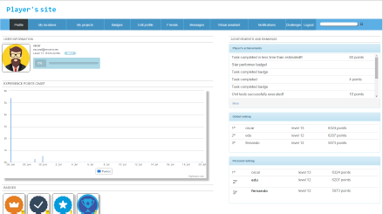

*Example of a dashboard with all functions on the same page*

**Chat/Discussion Board functionality (1)**

* Include a LLM/Generative AI chat feature where users can interact with AI
* Include a chat or a discussion board functionality where users on the gamification web app can interact with each other. Ask questions and receive responses from other users on the platform.

**User Profile Avatar (2)**

* Provide a functionality where users can choose an avatar as their profile picture. Provide many selections of avatars based on superheroes etc. that users can select from as their profile picture. Also, it can be used in their leaderboard images.

**Clickable items (3)**

* Include additional menu items so that clicking each of these items (leaderboard, points, levels, and medal) on the dashboard takes them to a more detailed page in the menu. – e.g., “Badges” where the user can see the details of the badges they have attained when they click on it on the dashboard.
  + Example The 5 badges can be grayed out to start with and when the user earns a badge, then the badge is activated. See example below

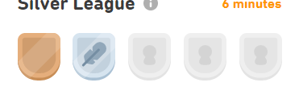

**Leagues (3)**

* Duration: The league will run for one week.
* Teams: Participants can join or create teams with their friends or other app users.
* Scoring: Users earn points for various activities, such as based on the points mentioned above. Users earn points based on the duration and timely completion of activities in leagues.
  + GREEN =Each correctly completed step earns **15 pts** à @08@
  + Additional **15 pts** for completing activities within a day (24hrs)
  + **10 points** for creating a league with at least 2 members
* Points are updated in real-time on a leaderboard for that league.

**Administrative Functions**

**User Creation (1)**

* Provide functionality where multiple users can be created in one user registration screen by the admin. The admin can specify the user LEARN IDs For example: Create usernames: **LEARN-001** to **LEARN-231,** specify the **SAP Application Server, Client ID** and **Initial Password** to create all the users from LEARN-001 to LEARN-231.

Currently, only one user can be created at a time and that’s tasking when hundreds of users need to be created.

**Administrators report for all user results (3)**

* Provide functionality where the administrator can see the results for all users in a report. The admin can also specify the user LEARN IDs For example: Create usernames: **LEARN-001** to **LEARN-231 and see their result or see a report for all users**.

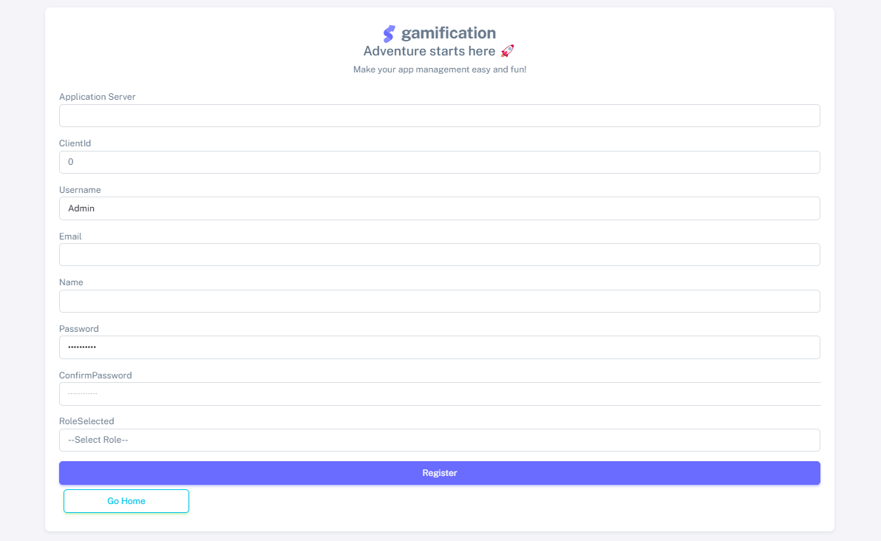

## Security Requirements

To be determined

## Error Handling

To be determined

## Special Considerations

Sample JSON Format for each user: i.e. LEARN-002, LEARN-003, and LEARN-023

{

"users": [

{

"user": "LEARN-002",

"Step1": "10",

"Step2": "10",

"Step3": "5",

"Step4": "0",

"Step5": "3",

"Step6": "10",

"Step7": "",

"Step8": "",

"Step9": "",

"Step10": "",

"Step11": "",

"Points": "38"

"Level": "6"

"Badge": "Master Data Badge"

},

{

"user": "LEARN-003",

"Step1": "10",

"Step2": "3",

"Step3": "",

"Step4": "",

"Step5": "",

"Step6": "",

"Step7": "",

"Step8": "",

"Step9": "",

"Step10": "",

"Step11": "",

"Points": "13"

"Level": "2"

"Badge": "Login Badge"

},

{

"user": "LEARN-023",

"Step1": "",

"Step2": "",

"Step3": "",

"Step4": "",

"Step5": "",

"Step6": "",

"Step7": "",

"Step8": "",

"Step9": "",

"Step10": "",

"Step11": ""

"Points": "0"

"Level": "0"

"Badge": "Login Badge"

}

]

}

**Note:**

UCC Milwaukee Dev System–

* The gamification research team was provided a dev system from UCC Milwaukee
* The current ABAP environment has preloaded GBI data set.
* The ABAP environment is latest version of 4.1
  + Global bike 4.1 development system – exclusive client for the use of this project.

**OData Service**

**URL of the Service**

https://<application_server>/sap/opu/odata/sap/ZUCC_GBM_SRV/<case_study>Set(Id=2,User='<user_id>')?$format=json&sap-client=<client>

**Placeholders**

|  |  |  |
| --- | --- | --- |
| Name | Description | Example |
| <application_server> | URL of the application server | E45z.2.ucc.md |
| <case_study> | ID of the case study (see list below) | MM |
| <user_id> | User ID | LEARN-034 |
| <client> | SAP-Client | 101 |

Example:

https://e45z.2.ucc.md/sap/opu/odata/sap/ZUCC_GBM_SRV/MMSet(Id=2,User='LEARN-034')?$format=json&sap-client=101

<https://e45z.4.ucc.md/sap/opu/odata/sap/ZUCC_GBM_SRV/MMSet(Id=2,User='LEARN-031')?$format=json&sap-client=111>

**Case studies**

CO_CCA, CO_CCA_F, CO_PC, CO_PC_F, EAM, EAM_F, FI, FI_AR_F, FI_F, HCMI, HCMI_F, HCMII, HCMII_F, MM, MM_F, PP, PP_F, PS, PS_F, QM, QM_F, SD, SD_F, WMI, WMI_F, WMII, WMII_F, WMIII, WMIII_F, WMIV, WMIV_F,

**Response**

{

"d":{

"__metadata":{

"id":"https://e45z.4.ucc.md/sap/opu/odata/sap/ZUCC_GBM_SRV/MMSet(Id=2,User='LEARN-034')",

"uri":"https://e45z.4.ucc.md/sap/opu/odata/sap/ZUCC_GBM_SRV/MMSet(Id=2,User='LEARN-034')",

"type":"ZUCC_GBM_SRV.MM"

},

"Id":2,

"User":"LEARN-034",

"Step1":"@0A@",

"Step2":"@0A@",

"Step3":"@0A@",

"Step4":"@0A@",

"Step5":"",

"Step6":"",

"Step7":"",

"Step8":"",

"Step9":"",

"Step10":"",

"Step11":"",

"Step12":"",

"Step13":"",

"FulfillmentMandatory":"33%",

"FulfillmentAll":"34%",

"toDetail":{

"__deferred":{

"uri":"https://e45z.4.ucc.md/sap/opu/odata/sap/ZUCC_GBM_SRV/MMSet(Id=2,User='LEARN-034')/toDetail"

}

}

}

}

Indicator

|  |  |
| --- | --- |
| Value | Meaning |
| @08@ | Everything is ok |
| @09@ | At least one optional field is wrong |
| @0A@ | At least one mandatory field is wrong |

**Questions/Requests**

Correct example URL for JSON output

<https://e45z.4.ucc.md/sap/opu/odata/sap/ZUCC_GBM_SRV/MM_FSet(Id=2,User='LEARN-031')?$format=json&sap-client=111>

1. “Step” Data Output is incorrect – Example Learn-031 from API

<https://e45z.4.ucc.md/sap/opu/odata/sap/ZUCC_GBM_SRV/MM_FSet(Id=2,User='LEARN-031')?$format=json&sap-client=111>

Change the steps in the JSON file to match the steps in the monitor…e.g., the above screenshot for the JSON file should be step1, step2, step3, step 5, step 7…

1. Data output is not complete. Following data points missing based on “Key Consideration” Section. Please keep the indicator symbol as it is in the current output
   1. Points per step* ~ has equivalent indicator provided but actual points needed as per key consideration section.
   2. Total Points
   3. Level
   4. Badges
2. How is the OData accessible in a production system? Currently in Postman, shows “401 unauthorized” Want to understand how we will access the API output into the gamified application when the API is moved into Dev.

Get this error - System.Net.Http.HttpRequestException: 'No connection could be made because the target machine actively refused it. (e45z.4.ucc.md:80)'

**Solution -**

Create an authorization header e.g., using postman header.

1. End point that provides User IDs (LEARN-IDs) of the users in a client for a particular case study/module (How many active users are in the system for a particular client?)
   1. May be the instructor can be providing the value?

**Solution -**

Erik to think through this request and provide a response by 2/14

e.g., LEARN-001, LEARN-005 have attempted step 1

1. End point that provides Case Study Module(s) of the users in a client for a specified user

**Solution -**

Erik to think through this request and provide a response by 2/14

e.g., Material Management, Enterprise Asset Management etc.…

Monday, Tuesday, or Friday

Erik availability – 10a -130p CET or after 430pm

Testing for UML Server

<http://trek.ucc.uwm.edu/sap/opu/odata/sap/ZUCC_GBM_SRV/MM_FSet(Id=2,User='LEARN-050')?$format=json&sap-client=101>